AIM: TO STUDY DDL CREATE AND DML INSER COMMANDS

CREATE TABLE STUDENT(ROLL_NO INT NOT NULL,NAME

VARCHAR(20) NOT NULL,SURNAME VARCHAR(20) NOT NULL,MOBILE INT(10) NOT

NULL,CLASS INT(12) NOT NULL,CONSTRAINT EID PRIMARY KEY (EID));



INSERT INTO STUDENT VALUES(1,"CHANDAN","VIRAYASH",9664547202,12);

INSERT INTO STUDENT VALUES(2,"DHIREN","GAMETI",9664547202,12);

INSERT INTO STUDENT VALUES(3,"RAHUL", "KUMAR",9664547202,12);

INSERT INTO STUDENT VALUES(4,"VIVEK", "CHAUHAN",9664547202,12);

INSERT INTO STUDENT VALUES(5,"AKHIL", "KUMAR",9664547202,12);

INSERT INTO STUDENT VALUES(6,"VIHSAL", "KUAMR",9664547202,12);

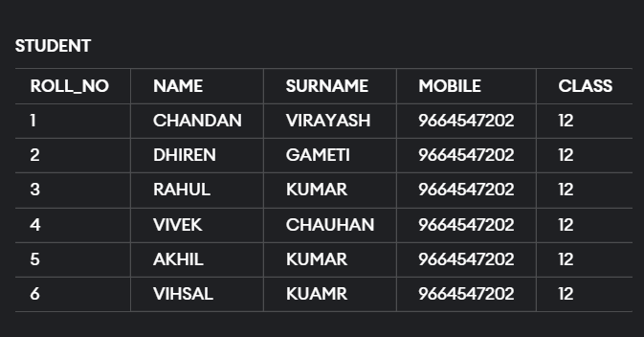

CREATE TABLE EMPLOYEES(EMPLOYEE_ID INT(50),FIRST_NAME

VARCHAR(10),EMAIL VARCHAR(20) NOT

NULL,PHONE_NUMBER INT(10) NOT NULL);



INSERT INTO EMPLOYEES

VALUES(1,"CHANDAN","VCHANDAN@GMAIL.COM",9638806095);

INSERT INTO EMPLOYEES

VALUES(2,"SHUDHIR","SSAHANI@GMAIL.COM",9638808098);

INSERT INTO EMPLOYEES

VALUES(3,"KRUNAL","RUNALH@GMAIL.COM",78787978878);

INSERT INTO EMPLOYEES

VALUES(4,"ANAND","AKUMAR@GMAIL.COM",9278272527);

INSERT INTO EMPLOYEES

VALUES(5,"NITESH","NIITESH@GMAIL.COM",8986855669);

